Article

Title No More Than 20 Words Total pages: 18
Author Name¹, Author Name²
^{1, 2} University, Study Program, City, Indonesia

Submission Track |  | ABSTRACT
Recieved: Mm, dd, yyyy  Final Revision: Mm, dd, yyyy  Available Online: Mm, dd, yyyy |  | The abstract should summarize the content of the paper. Try to keep the abstract below 180 words. Do not make references nor display equations in the abstract. The journal will be printed from the same-sized copy prepared by you. Your manuscript should be printed on A4 paper (21.0 cm x 29.7 cm). It is imperative that the margins and style described below be adhered to carefully. This will enable us to keep uniformity in the final printed copies of the Journal. Please keep in mind that the manuscript you prepare will be photographed and printed as it is received. Readability of copy is of paramount importance. An abstract must contain information about What did you do? How did you do it? What did you find? Why are these findings useful and important?
Keyword
Write, No more, Than, five, Keywords
Correspondence
E-mail:
author1@email.com
author2@email.com

INTRODUCTION
The introduction of the paper should explain the nature of the problem, previous work, purpose, and the contribution of the paper. The contents of each section may be provided to understand easily about the paper.

LITERATURES REVIEW
There are numerous studies in literature. Here only some of them similar to our study will be given.

FRAMEWORK (Optional)
Description of the framework

METHODS
The methods section describes the rationale for the application of specific procedures or techniques used to identify, select, and analyze information applied to understanding the research problem, thereby, allowing the reader to critically evaluate a study’s overall validity and reliability. The methodology section of a research paper answers two main questions: How was the data collected or generated? And, how was it analyzed? The writing should be direct and precise and always written in the past tense.

RESULTS
The results section is where you report the findings of your study based upon the methodology [or methodologies] you applied to gather information. The results section should simply state the findings of the research arranged in a logical sequence without bias or interpretation. A section describing results [or "findings"] is particularly necessary if your paper includes data generated from your own research.
Equation
The writing of formulas should follow the format provided in the specified example. Each formula used in the manuscript must be assigned an equation number and explicitly referred to in the explanatory paragraph. Thus, the formulas do not stand alone but are directly connected to the conceptual, methodological, or analytical discussion being presented.
(1)
$$d\left(x,c\right)=\sqrt{\sum_{i=1}^{n}{{\left(x_{i}-c_{i}\right)}^{2}}}$$
Table
Place tables as close as possible to the text they refer to and aligned center. A table is labeled Table and given a number (e.g., Table 1. Sample Datasheet with Attributes in Linguistic Term) it should be numbered consecutively. The table label and caption or title appears 10pt space above the table, 10pt space after the text or paragraph if any; it should be uniforms fonts and font size, and use 10pt font size and Times New Roman style, capitalized similar to paper title, aligned center and bold face. Sources and notes appear below the table, aligned left. All tables must be in portrait orientation.
For Example:

Table 1. Table captions should be placed above the table
Graphics | Top | In-between | Bottom
Tables | End | Last | First
Figures | Good | Similar | Very well

Figure
Place figures as close as possible to the text they refer to and aligned center. Photos, graphs, charts or diagram should be labeled Figure (do not abbreviate) and appear 6pt space below the figure, 12pt space before the next text or paragraph, and assigned a number consecutively. The label and title should be in line with the figure number (e.g., Figure 1. Location Error Rate of Three Schemes), it should be uniforms fonts and font size; use 10pt font size and Helvetica style,capitalized similar to paper title, aligned center and bold face. Source (if any) appear underneath, flush left. Figures should be at good enough quality. Minimum image dimensions are 6 cm (2.3622 in) wide by 6 cm (2.3622 in) high.
For Example:

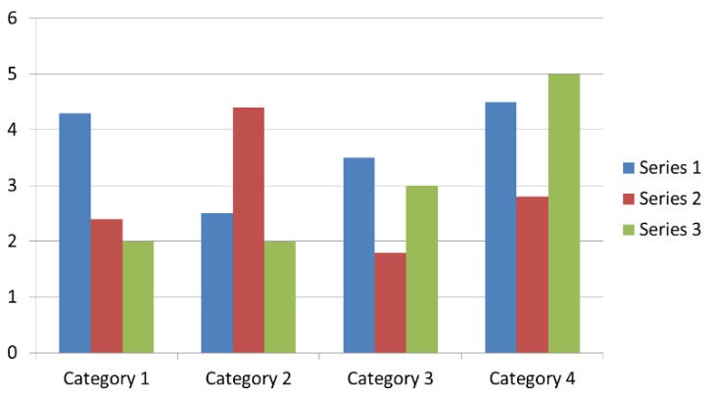
Figure 1. If necessary, the images can be extended both columns

DISCUSSION
The purpose of the discussion is to interpret and describe the significance of your findings in light of what was already known about the research problem being investigated, and to explain any new understanding or insights about the problem after you've taken the findings into consideration. The discussion will always connect to the introduction by way of the research questions or hypotheses you posed and the literature you reviewed, but it does not simply repeat or rearrange the introduction; the discussion should always explain how your study has moved the reader's understanding of the research problem forward from where you left them at the end of the introduction.

CONCLUSION
The conclusion is intended to help the reader understand why your research should matter to them after they have finished reading the paper. A conclusion is not merely a summary of the main topics covered or a re-statement of your research problem, but a synthesis of key points and, if applicable, where you recommend new areas for future research. For most essays, one well-developed paragraph is sufficient for a conclusion, although in some cases, a two or three paragraph conclusion may be required.

ACKNOWLEDGEMENT
The authors would like to express our gratitude for the support provided by Faculty of Science and technology. The financial assistance from Research, Publication and Community Service Department Buddhi Dharma University is also greatly acknowledged.
(Use acknowledgement if research uses UBD financial assistance)

REFERENCES (Min 25)
Using IEEE Format Ex:

[1] A. A. Name, and B. B. Name, Book Title, Place: Press, Year.
[2] A. Name, and B. Name, "Journal Paper Title", Journal Name, Vol. X, No. X, Year, pp. xxx-xxx.
[3] A. Name, "Dissertation Title", M.S.(or Ph.D.) thesis, Department, University, City, Country, Year.
[4] A. A. Name, "Conference Paper Title", in Conference Name, Year, Vol. x, pp. xxx-xxx.

Example:

[1] S. M. Metev and V. P. Veiko, Laser Assisted Microtechnology, 2nd ed., R. M. Osgood, Jr.,
Ed. Berlin, Germany: Springer-Verlag, 1998.
[2] J. Breckling, Ed., The Analysis of Directional Time Series: Applications to Wind
Speed and Direction, ser. Lecture Notes in Statistics. Berlin, Germany: Springer,
1989, vol. 61.
[3] S. Zhang, C. Zhu, J. K. O. Sin, and P. K. T. Mok, “A novel ultrathin elevated channel low-
temperature poly-Si TFT,” IEEE Electron Device Lett., vol. 20, pp. 569–571, Nov.
1999.

BIOGRAPHY

Daniel Silaban is a sixth-semester undergraduate student in the Informatics Engineering Study Program, Faculty of Computer Science, Universitas Katolik Santo Thomas, Medan, Indonesia. His research interests include data mining and its applications in data analysis and decision support systems. He is actively involved in academic and research activities to broaden his knowledge and expertise in information technology.

Gracia Simatupang is a sixth-semester undergraduate student in the Informatics Engineering Study Program, Faculty of Computer Science, Universitas Katolik Santo Thomas, Medan, Indonesia. Her research interests include data mining and its applications in data analysis, as well as web development and artificial intelligence. She is actively involved in academic and organizational activities to enhance her knowledge and skills in information technology.

Fasrad Juang Harefa is an undergraduate student in the Informatics Engineering Study Program, Faculty of Computer Science, Universitas Katolik Santo Thomas, Medan, Indonesia, and began his studies in 2023. In addition to actively participating in academic activities, he is also involved in the computer network club. His areas of interest and expertise include robotics, hacking, and computer networks. Currently, he continues to enhance his knowledge and skills in information technology through coursework, research activities, and various software development projects.

Lotar Mateus Sinaga is a lecturer in the Informatics Engineering Study Program, Faculty of Computer Science, Universitas Katolik Santo Thomas, Medan, Indonesia. He is actively involved in teaching, research, and community service activities. His academic interests include computer networks, server administration, and the application of information technology in various domains

